**2015 Building Research Capacity with Indigenous Communities - Workshop**

**Tuesday, March 17th, 2015**

**8:30 am - 3:30 pm**

**45 Dedam St., St. Mary’s First Nation Cultural Centre**

**Fredericton, NB**

**Workshop Registration Form**

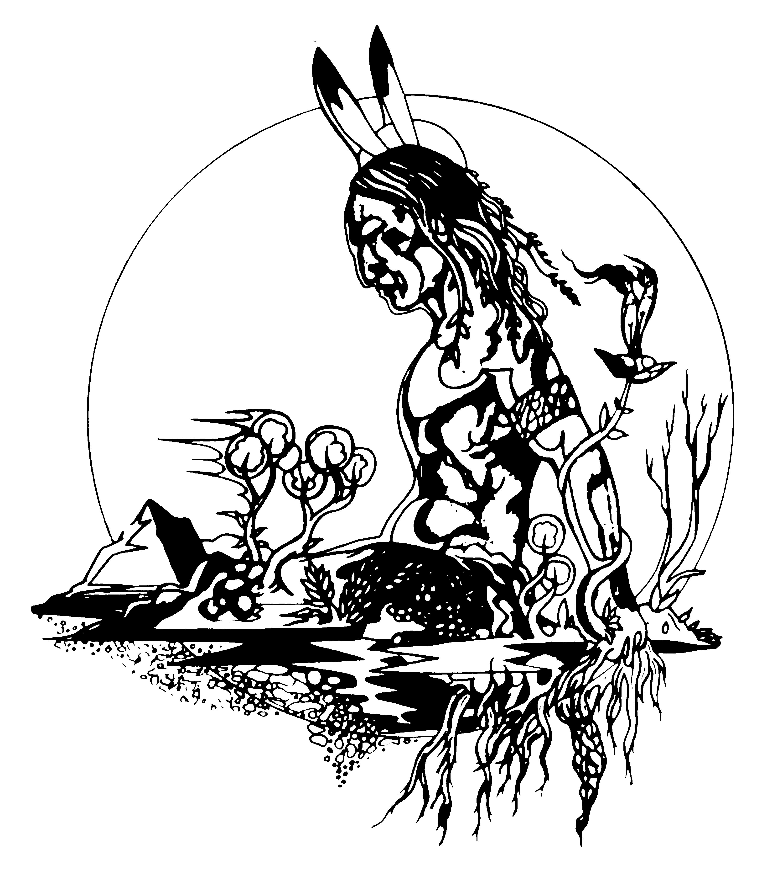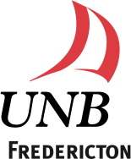

|  |  |  |  |  |
| --- | --- | --- | --- | --- |
| **Participant Information** | | | | |
| **First name:** | | | **Last Name:** | |
| **Affiliation (Organization / Company):** | | | | |
| **Street Address:** | | | | |
| **City:** | **Province:** | | | **Postal Code:** |
| **Phone:** | | **Email:** | | |

This workshop is sponsored by The Atlantic Aboriginal Economic Development Integrated Research Program (AAEDIRP) and developed in partnership with The Mi’kmaq-Wolostoqey Centre (UNB) and the Faculty of Education (UNB).