
Get ready for a mini-ehpicTM!!!
Workshop on interprofessional education and collaboration

Donna Romano, RN., MSc, PhD, CPMHN(C)  Donna Romano is the Interprofessional Care & Education Leader at UHN and lectures at the Bloomberg Faculty of Nursing at the University of Toronto (UT). Donna began her Nursing studies at McMaster University, receiving her Bachelor of Science in Nursing, while later completing graduate school from the Faculty of Nursing, at UT. Her 20 year Nursing career has specialized in Mental Health Nursing, including clinical and hospital administrative roles. Her clinical and research interests centre around the recovery process in first episode schizophrenia, fostering effective inter-professional teamwork, and researching the development of trust on health care teams. Donna was part of the panel that developed a Registered Nursing Association of Ontario RNAO best practice guideline for healthy work environments. In 2009, she completed her PhD at the Institute of Medical Science University of Toronto. Her dissertation focused on “Exploring the Process of Recovery from a First Episode of Schizophrenia”.  donna.romano@uhn.ca | 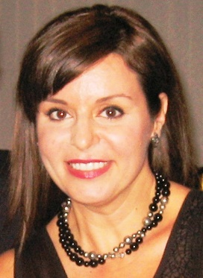
Lynne Sinclair, MA (Ad Ed), BSc (PT), PT Reg (Ont.)  Lynne Sinclair is the Innovative Program and External Development Lead, Centre for Interprofessional Education (IPE), University of Toronto (UT), an Educational Consultant and was appointed as the first Interprofessional Education Scholar-in-Residence at The School of Community and Health Studies at Centennial College. Lynne holds an appointment as an Assistant Professor with the Department of Physical Therapy, Faculty of Medicine on the Faculty of Medicine. Lynne is widely invited as a keynote speaker for conferences, educational events and courses throughout Canada, the USA, Australia, Denmark and Saudi Arabia. She has been a principal investigator or investigator on numerous education initiatives and research projects. She has been the Associate Director at the Centre for IPE at UT and has served as the Associate Chair of the Department of Physical Therapy at UT. Lynne’s passion for physical therapy and interprofessional education was ignited during her seven years at Toronto Rehabilitation Institute where she was the Director of Education for 12 health disciplines. In 2008, she received the UT Faculty of Medicine - Helen P. Batty Award in Faculty Development for Teaching Excellence along with an Honorary Bachelor Degree in Applied Studies by Humber College Institute of Technology and Advanced Learning in June 2013.  Lynne.sinclair@uhn.ca | 

